
Computer Networks Lab
Course Code: CL3001
Credit Hours: 01
Fall 2024
Lab Instructor: Engr. Muhammad Qasim

Lab 01: Cisco Packet Tracer and Wireshark Installation
Introduction to Cisco Packet Tracer
Cisco Packet Tracer:
Packet Tracer is an exciting network design, simulation and modelling tool that allows you to develop your skill set in networking, cybersecurity, and the Internet of Things (IoT). It allows you to model complex systems without the need for dedicated equipment. It is used across numerous Cisco Academy courses to help develop and assess the skill set necessary for successful completion of the course.
Use Cisco Packet Tracer to:
- Put your knowledge into practice
- Prepare for a certification exam
- Sharpen your skills for a job interview
Link: lms.netacad.com (for Cisco Academy free courses)
Steps to download Cisco Packet Tracer
- Goto the given link and create an account on Cisco Netacad
Link: www.netacad.com
- Goto resources tab and click on Download Packet Tracer
- Click on the appropriate link to download the Cisco packet tracer exe file compatible with your operating system
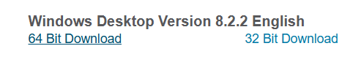
- After downloading the exe file, click on it to install the Cisco Packet Tracer. The below window will appear after clicking the exe file.
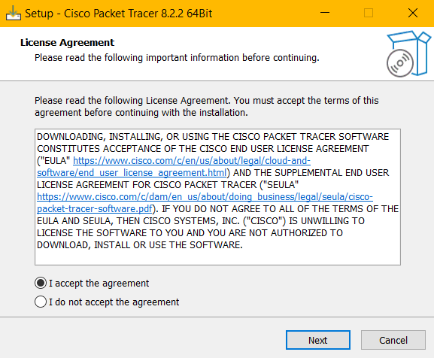
- Follow the default options by clicking the next button and then click on install.
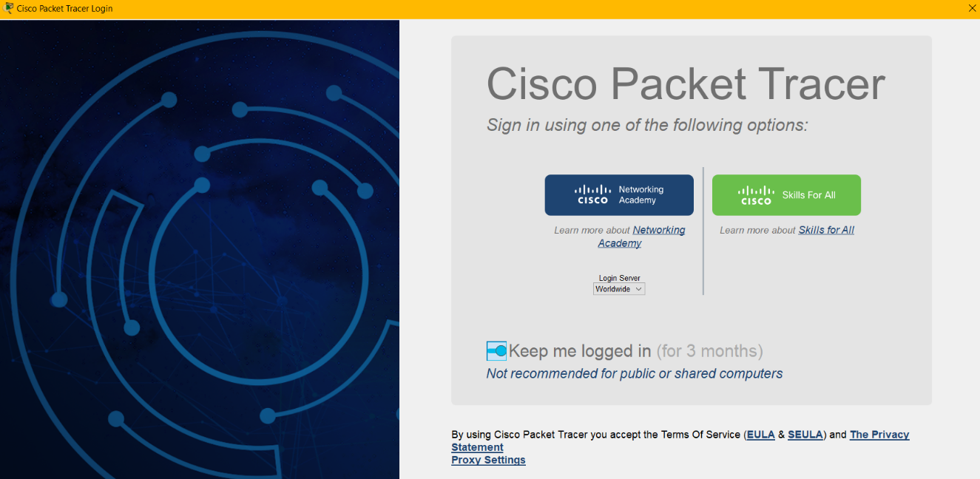
- After the installation, the window below will appear when you open the Cisco Packet tracer. This window requires your signature. Click on Cisco Networking Academy to log into your account.
Click here

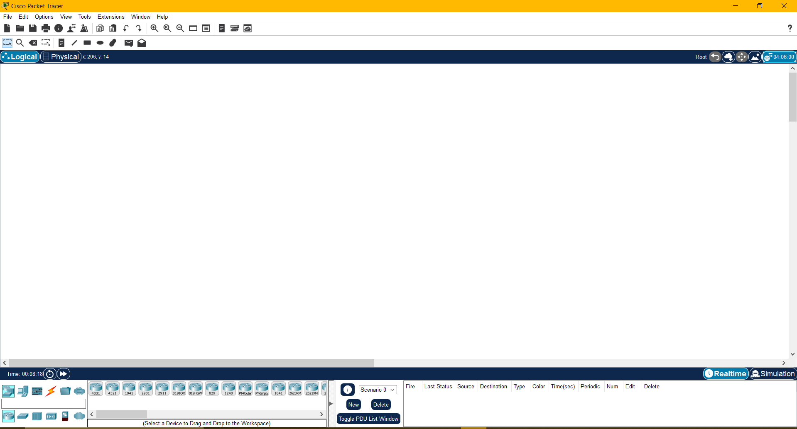
- After signing in to your account, the interface of the Cisco packet tracer will appear.

Woohoo! You have successfully installed the Cisco Packet tracer.

Wireshark Installation
Wireshark:
Wireshark is a software protocol analyzer, or packet sniffer application, used for network troubleshooting, analysis, software and protocol development, and education. As data streams travel back and forth over the network, the sniffer captures each protocol data unit (PDU) and can decode and analyze its content according to the appropriate RFC, or other specifications. Wireshark is a useful tool for anyone working with networks and can be used with most labs in the CCNA courses for data analysis and troubleshooting. This lab provides instructions for downloading and installing Wireshark.
Instructions:
Wireshark has become the industry standard packet sniffer program used by network engineers. This
open-source software is available for many different operating systems, including Windows, Mac, and Linux. You will download and install the Wireshark software program on your PC in this lab.
Step 1: Download Wireshark.
a. Wireshark can be downloaded from www.wireshark.org.
b. Choose the software version you need based on your PC’s architecture and operating system.
For instance, if you have a 64-bit PC running Windows, choose Windows Installer (64-bit).
After making a selection, the download should start. The location of the downloaded file depends
on the browser and operating system that you use. For Windows users, the default location is the
Downloads folder.
Step 2: Install Wireshark.
- The downloaded file is Wireshark-win64-x.x.x.exe, where x represents the version number if you downloaded the 64-bit version. Double-click the file to start the installation process. Respond to any security messages that may be displayed on your screen. If you already have a copy of Wireshark on your PC, you will be prompted to uninstall the old version before installing the new version. You should remove the old version of Wireshark before installing another version. Click Yes to uninstall the previous version of Wireshark.
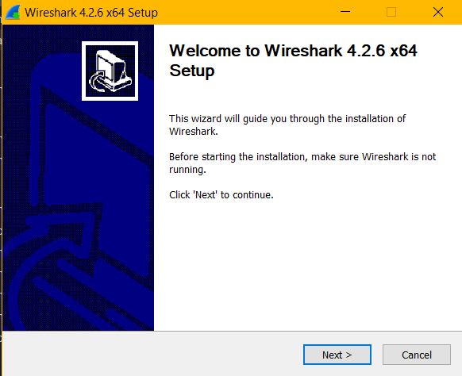
- If this is your first time installing Wireshark or after you have completed the uninstall process, you will navigate to the Wireshark Setup wizard. Click Next.
- Continue advancing through the installation process. Click I Agree when the License Agreement window displays.
- Keep the default settings on the Choose Components window and click Next.
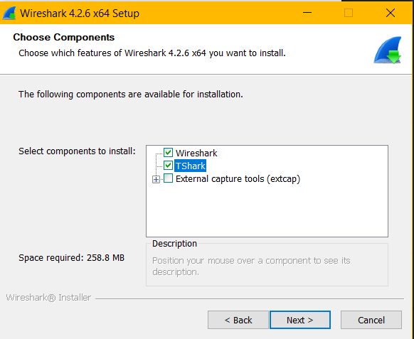
- Choose your desired shortcut options and click Next.
- You can change the installation location of Wireshark, but unless you have limited disk space, it is recommended that you keep the default location. Click Next to continue.
- To capture live network data, Npcap must be installed on your PC. If Npcap is already installed on your PC, the Install check box will be unchecked. If your installed version of Npcap is older than the version that comes with Wireshark, it is recommended that you allow the newer version to be installed by clicking the Install Npcap x.x.x (version number) check box. Click Next to continue.
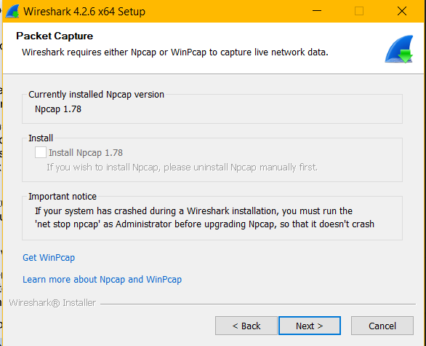
- Do NOT install USBPcap for normal traffic capture. Do NOT select the checkbox to install USBPcap. USBPcap is experimental, and it could cause USB problems on your PC. Click Install to continue.
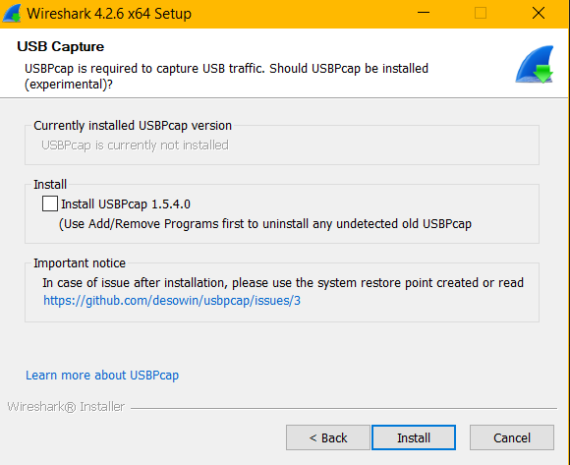
- Wireshark starts installing its files and displays the installation status.
- In a separate window, accept the license agreement in the Npcap Setup Wizard if installing Npcap. Click I Agree to continue. Click Install to install Npcap. Click Next to finish the Npcap installation and click Finish to exit the Npcap installation.
- Click Next when the Wireshark installation is complete.
- Click Finish to complete the Wireshark install process. Reboot the computer if necessary.

Introduction to Basic Computer Networking Components and Devices
Router:
A router is a device that forwards data packets between computer networks. It directs traffic on the internet by determining the best path for data to travel from one network to another. Think of it as a traffic manager for your data, ensuring it reaches its destination efficiently.
Figure:
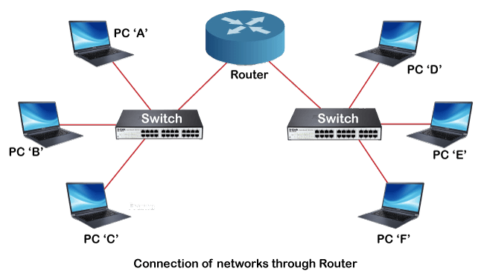

Switch:
A switch is a networking device that connects multiple devices within a local area network (LAN) and uses packet switching to forward data to its destination. Unlike a router, which connects different networks, a switch operates within a single network, directing data only to the specific device it is intended for, thus improving network efficiency and security.
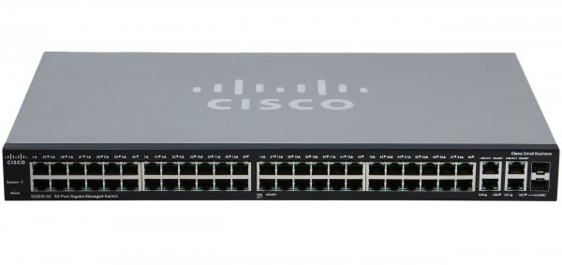
Modem:
Modem stands for Modulator/Demodulator. The modem is a networking device used to connect devices connected in the network to the internet. The main function of a modem is to convert the analog signals from telephone wire into a digital form. In digital form, these converted signals are stored as 0s and 1s.
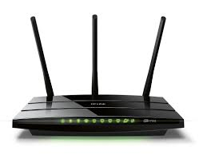
Gateway:
A gateway is a device that connects different networks, allowing data to flow between them. It acts as a bridge, often connecting a local network to the internet.
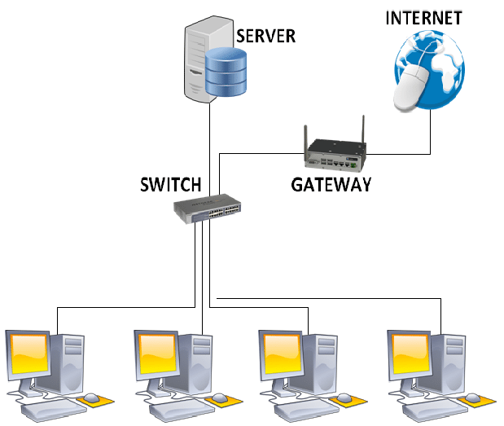

Ethernet Cable:
An Ethernet cable is a network cable used to connect devices within a local area network (LAN), such as computers, routers, and switches. It facilitates the transmission of data and information between these devices, providing a reliable and fast connection. Ethernet cables come in various categories, such as Cat5e, Cat6, and Cat8, each offering different speeds and performance levels.
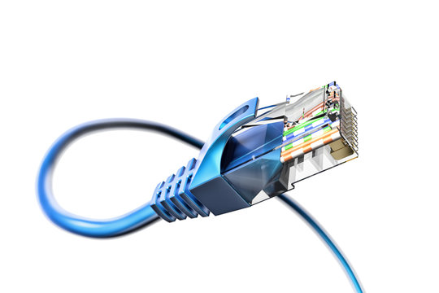
Cross over cable:
A crossover cable is a type of Ethernet cable used to connect two similar devices directly, such as two computers or two switches
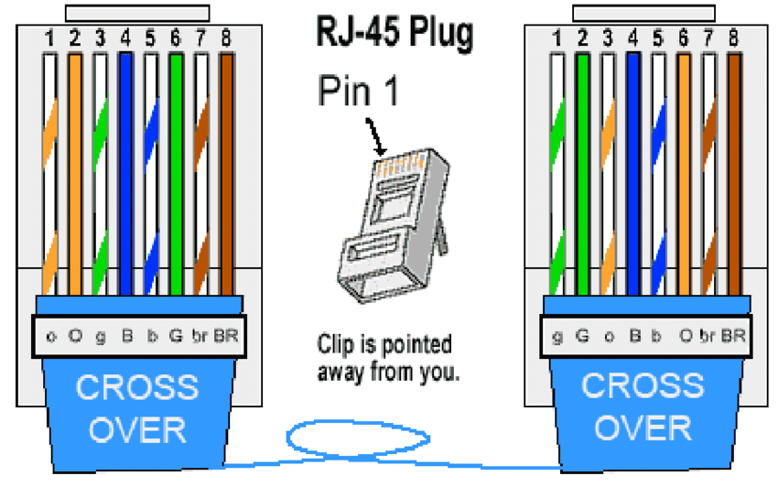
Straight through cable:
A straight-through cable is a type of Ethernet cable used to connect different types of devices within a network, such as a computer to a switch or a router to a modem. The wiring configuration is the same on both ends of the cable, meaning each pin on one end is connected to the corresponding pin on the other end.
